**Chromium for Application**

**What is Chrome for Application**

***Chromium for Application*** is a Windows Application Development Framework based on chromium project. It allows windows developers to develop **Application Systems** based on chromium. Its basic features are as follows:

1. The core foundation of the application system has full Chromium functions, so the application itself is a modern web browser. The differences between the application system and Chrome browser are as follows: the first window is the user-defined application window, and the second and subsequent instances are the same as the standard Chrome browser. For details of the differences, please refer to the official Google Documents.

|  |  |
| --- | --- |
| The first instance window of the application is a user-defined application window. | Generally speaking, a developer can use his familiar technology to provide a main window for his application to show the main outline of his application. Due to some objective limitations of the programming language, the main window is provided based on binary mode. Chromium for application uses HTML rules to define the main window of an application program, which provides developers with maximum descriptive flexibility. Thanks to the built-in web mechanism, the main window of an application program can be fully personalized. |
|  | Launch the second instance and subsequent instances of the application system. Like Chrome browser, the application system will launch the built-in browser, which looks like chrome based browser and is a complete browser window. Unlike other browsers, the page may contain application components |
|  | With the built-in browser of the application, the application system can open any number of "application pages", each of which represents a specific application module. This type of application is based on page organization, which provides great flexibility to the application system. , The development team can provide new applications in the form of Web pages at any time and at any stage, thereby solving the scalability problem of the application system in a more unified mode. |

2. Support the full .Net framework. In addition to the standard WinForm, WPF and other UI components, the application also supports the web browser as a UI component, allows the web browser as a child window of the .Net UI component, and supports the interoperability between .Net and JavaScript. Web pages support .Net UI components, allowing developers to write application-oriented web pages with standard DOM and .Net (UI) components. Based on the powerful features of the .NET Framework, developers can fully combine the inherent advantages of web pages to develop application software that conforms to the characteristics of the Internet.

|  |  |
| --- | --- |
|  | ***Chromium for Application*** allows browser windows to support Native Win32 UI Component Such as .Net UI components, MFC, Java etc. which enables application software to have the double advantages of modern browser and Win32 components in terms of expressiveness. Developers can fully combine the technical advantages of Win32 and web, and then build a powerful application system |
|  | Based on Chromium for application, every object, such as WinForm, can be a web page element. Web page can directly handle all aspects of the object, such as the event of the object. As shown in the figure, the event of the size change of the form object is handled by the web page |
|  | Implementing win32 and javascript interoperation on the web page can make the Function and UI of the application software reasonably migrate to the web side, so that the application software has the ability of the web server to effectively control the front end |
| Web Browser as SubWindow | Browser window, as a sub window of Win32 UI component, enables developers to use mature Win32 UI technology and Web UI technology to organize more powerful and interactive application interfaces. |

3. When more and more software functions depend on the interoperation of Web pages and Windows Application Framework such as MFC, .NET Framework, Java, the number of application pages will gradually increase, and the web part of the application system will become more and more important. From this point of view, Chromium for Application gives The development of application systems provides another aspect of Web-based technology, which means that each application system will have a Web-based back-end development, which is a way for software to transition to software services in the Internet era.

**How Chrome for Application Work**

首先，您需要Visual Studio 2019或者2017。安装Visual Studio之后，可以在<https://marketplace.visualstudio.com/items?itemName=TangramDev.tangram-wizard> 下载Chromium.NET Wizard，正确下载之后，会在Visual Stdio IDE里面安装Wizard。

1、您需要创建一个新工程，如图，用“WebBrowser”关键词过滤Wizard，会看到如下画面：

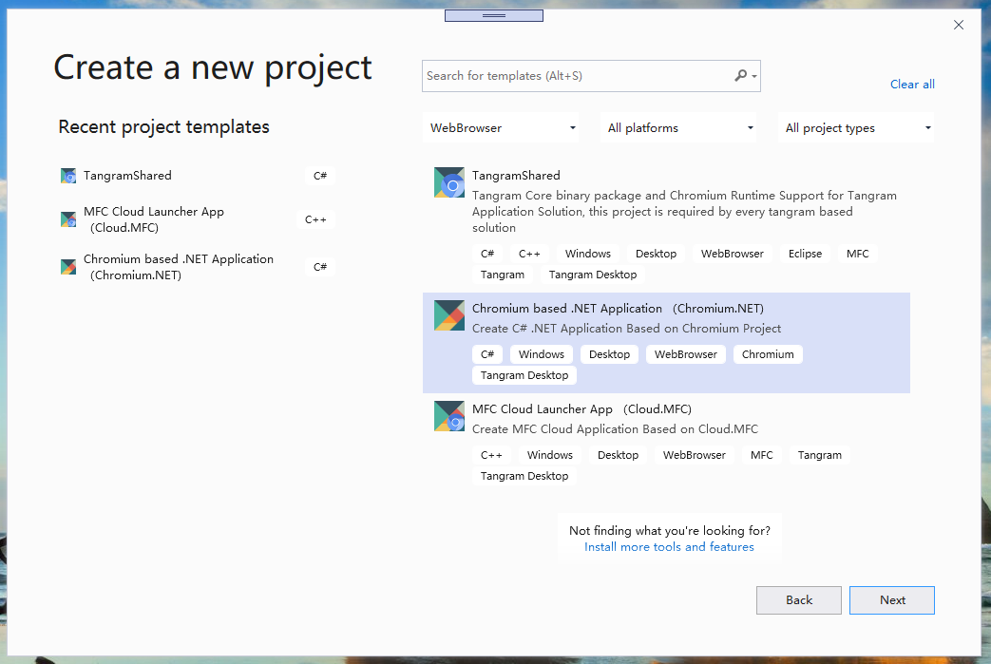

选择“Chromium Based .NET Application”，点击“Next”按钮进入下一步：

点击“Create”，会看到如下窗口：

按“Finish”按钮，我们创建了一个新工程，这个工程目前还不能正常工作。

2、在如上的Solution添加一个“Tangram Shared”工程，完成正确的工程配置以及获得必要的二进制组件包，具体操作如下：首先，您需要打开“新工程向导”，选择“Tangram Shared”工程：

每个Chromium on .NET项目需要一个“Tangram Shared”工程，以确保所有的代码可以正常工作，创建Tangram Shared工程之后，一个基本的Solution如下所示：

完成以上两个步骤，既可以正常编译了，实际运行会得到如下界面：

这样，我们就完成了Chromium on .NET的基本使用步骤，我们会在后续的工作中提供进一步的细节。